**Design Phase & Testing Phase Document : Data Security**

**DOCUMENTATION OF USE CASE DIAGRAM**

● The actors in use case diagram are client and system admin

● The use cases are request for logging into the system,feeds data to be confidential,requests for data,logs off the system and checks for confidentiality.

● The actors use the use case are denoted by the arrow.

● The request for logging into the system use case is the request made by client for logging in.

● The feeds data to be confidential use case is for storing the data in securely ● The,requests for data use case is used to get the information/data. ● The logging out use case is to log out off the system.

● The checks for confidentiality use case is to check if the data inserted or is requested in a confidential way.

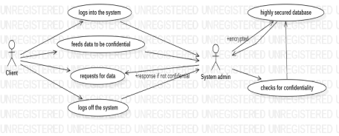**DOCUMENTATION OF CLASS DIAGRAM**

● **PASSENGER**- The passenger has attributes such as name, gender, email id, address and passenger_id. The passenger needs to fill the details that are required to book a ticket. After booking the person can view the status of the ticket booked.

● **TICKET**- The ticket has attributes such as source, destination, Date of booking, passenger_id and vehicle_no.

● **BUS**- The bus has attributes such as bus type, driver details, start_time and end_time. This is a medium of transportation passengers want to travel. ● **PAYMENT**- The payment has attributes such as payment_id, amount, mode of payment and no of tickets. Passenger makes the payment for the ticket he/she booked.

● **CANCELLATION**- The cancellation has attributes such as cancellation_id and refund amount. If a passenger requests for cancellation then it gets canceled and the amount will be refunded.

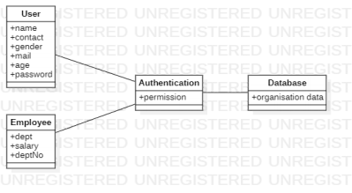● **USER-** The user has attributes such as name, contact, gender, mail, age and password. It contains all the details for a user.

● **EMPLOYEE-** The employee has attributes such as department, salary and deptNo which are the details of the employee.

● **AUTHENTICATION-** The authentication has attribute permission. The authentication gets the details from the user and employee and verifies with the database and issues the permissions.

● **DATABASE-** The database has attributes such as organisation data. The purpose of a database is to store the data and organise the data in a sequential order.

**DOCUMENTATION OF SEQUENCE DIAGRAM**

A sequence diagram represents the sequence and interactions of a given scenario. Sequence diagrams can capture most of the information about the system. Most object to object interactions and operations are considered events and events include signals, inputs, decisions, interrupts, transitions and actions to or from users or external devices.

An event also is considered to be any action by an object that sends information. The event line represents a message sent from one object to another, in which the “form” object is requesting an operation be performed by the “to” object. The “to” object performs the operation using a method that the class contains.

**Sequence diagram describes the sequence of steps:**

Data Security Sequence diagram:

● Network security is one of the most important aspects to consider ● when working over the internet, LAN or other method. While there is no network that is immune to attacks, a stable and efficient network security system is essential to protecting client data. A good data security system helps business reduce the risk of falling of data theft

● It also ensures that shared data is kept secure. Getting connected to the internet means that we will receive lots of traffic. Huge traffic can cause stability problems and may lead to vulnerabilities in the system. Network security promotes reliability of our network by preventing lagging and downtimes through continuous monitoring of any suspicious transaction that can crippling the system.

● Sequence diagram describes the sequence of steps:

● Admin are used to login and fill the details, system verify authentication system and give access to the data base.

● User first register and login the details then system verify authentication system and give access to the data base.

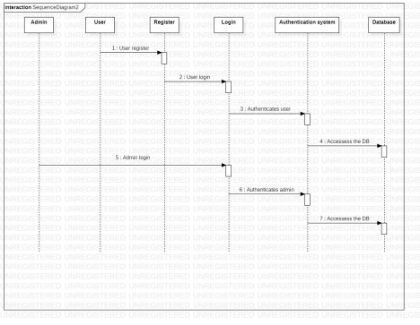

**DOCUMENTATION OF COLLABORATION DIAGRAM** • The data in an organisation is make sure to be secured through the following steps here are given few check points through which the process is done. initially when users signs into the organisation through a system, authenticator system authenticates the user to avoid the unauthorised users. Then chooses an algorithm and then encryption and decryption of the data is done as per the requirement and if this process is success then the user signs off from system.

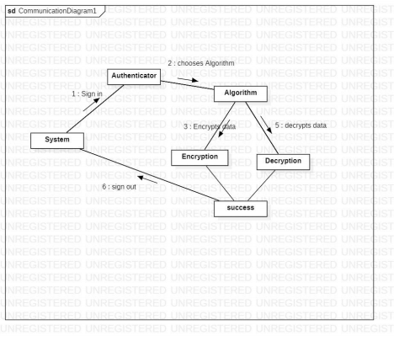**DOCUMENTATION OF STATE CHART DIAGRAM** ● The states of the Data Security system are denoted in the state chart diagram ● Initially the user who can be admin or the customer can enter into the organisation server by logging into his system

● then algorithm is applied on the data thereby encryption or decryption is performed.

● If successfully above process is done then he successful in logout this system

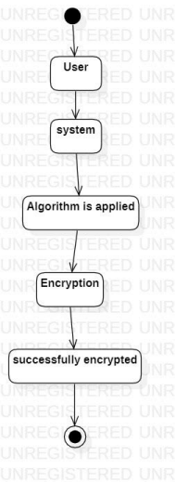

**DOCUMENTATION OF ACTIVITY DIAGRAM**

• The activities in the passport automation system are open system, Sign in, choose algorithm, encrytion/decryption of file, sign out, system close.

• In the login by giving username and password and then login into application after that choose the algorithm for file encryption/decryption.

• After choosing algorithm the process becomes successful and can sign out and close the system.

**DOCUMENTATION OF COMPONENT DIAGRAM** • The components in the Data Security system are System, user, authentication system and database server

• Here the user is dependent on the authentication system because after the user logins into system they must be authenticated and database serveris the dependent over the authentication system because if system is authenticated successfully then only the access is given to the database server

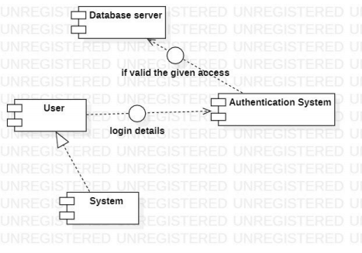**DOCUMENTATION OF DEPLOYMENT DIAGRAM**

The device nodes are organisation, employee, user, security system and database server

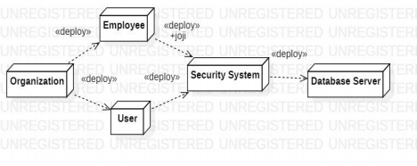**DOCUMENTATION OF PACKAGE DIAGRAM**

4 layers in the package diagram of data security customers organisation security system and database server

• The customers represent the uses of the organisation.

• The organisation represents the employees and the admin

• Best security system represents the the authentication, encryption-decryption validation and can include many other which can be helpful for a organisation to make it more secure.

• The database server is of the organisation, contains all the information of it.